R E V I E W

A Review on Hangman Game in Python Program

Abdal Raheman Khan

Introduction  
Hangman is a classic word guessing game that involves guessing a hidden word by suggesting letters or the entire word. Each incorrect guess results in the drawing of a guess out of six, and the game ends when all the six guesses are over (i.e., the player loses) or the word is correctly guessed (i.e., the player wins).

Features  
The Hangman game has the following features:

* Random selection of word for guessing
* Guessing of letters or entire words
* Displaying the current state of the word with dashes and revealed letters
* Tracking of number of guesses remaining
* Basic error handling to prevent invalid input

How to play  
To play the Hangman game, follow these steps:

1. The game starts by selecting a random word for the player to guess.
2. The player is presented with a series of dashes, representing the letters of the word to be guessed.
3. The player can guess a letter or the entire word by typing it in the terminal or command prompt.
4. If the player guesses a letter that is not in the word, a part of the "hangman" figure is drawn.
5. If the player guesses a letter that is in the word, the letter is revealed in the corresponding position(s) in the word.
6. If the player guesses the entire word correctly, the game is won. If the player runs out of guesses before guessing the word, the game is lost.
7. After each guess, the current state of the word (with revealed letters and remaining dashes) is displayed in the terminal or command prompt.
8. The game can be played multiple times with different random words by selecting "Y" when prompted after a game ends.

Example  
Let’s say the chosen word is "banana" and the player guesses "a" and "n". The current state of the word would be:

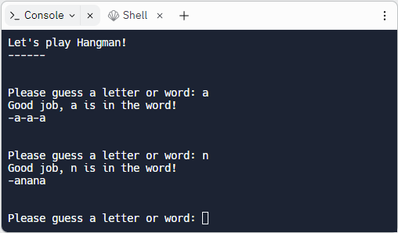

Error handling  
The Hangman game has basic error handling features that prevent the program from crashing when invalid input is entered. If an invalid guess is entered (such as a number or a string with more than one character), the program will display an error message and prompt the user to enter a valid guess.

User interface  
The Hangman game has a simple and intuitive user interface that prompts the user for input and displays the current state of the word on the screen after each guess.

Conclusion  
In conclusion, the Hangman game is a classic word guessing game that provides a fun and engaging experience for the user. It can be played multiple times with different random words.